Dredging in RMIP for Core Materials in a manner to contribute in navigation – Environmental Code of Practices

Background

Introduction
The construction materials required for embankment, road, river bank revetment, and other project components of the River Management Improvement Program (RMIP) will include earth, geo-bags, hard rock, sand, geo-textile, stone-chips, brick chips, asphalt, cement, steel for concrete reinforcement, road furniture, and other accessories. Some of these materials will be obtained from within the project influence area: sand from the river and earth from the existing embankment. The RMIP carefully balances its sourcing of sediment from the braided river belt of the Jamuna with environmental requirements, especially considering endangered species, while providing the option to improve the fish habitat and navigation alongside the protected river reach. The Riverbank protection will also result in a deeper channel parallel to the riverbank, which will provide habitat for fish and also improve navigation conditions due to river stabilization in the long run.

Objective of this Additional Addendum
Following completion of the project’s EIA, the Government of Bangladesh has decided to further explore and demonstrate the ways that the proposed project may contribute to enhanced navigation through core material extraction. The objective of this addendum is therefore to (i) extensively evaluate the long term and short term, direct and indirect impact of the project on navigation (based on core material collection related dredging); (ii) validate and further strengthen the existing project EMP by introducing an additional Environmental Code of Practice (ECoP) on Dredging, to supplement the existing ECoP #9 on Sand Extraction already included in the project EMP. This new ECoP therefore provides more in-depth coverage and requirements to ensure that the range of impacts from sand extraction activities that may occur within the river / in submerged areas (as opposed to only in shallow and exposed areas of riverbanks and shoals), and which therefore involve dredging (as opposed to more general methods of sand extraction from exposed areas), are fully mitigated and managed. ECoP #9 and this new ECoP are overlapping, but both will be included in the Bid Documents. This addendum will also be included in the already agreed EMP.

Scope of Dredging under RMIP-Phase I

The RMIP works will take place along a heavily eroding 50km long section at the western main channel between Sariakandi and Sirajganj. A total of approximately 23 million m³ of material would be extracted from the river:
- 11 million m³ of sand for filling of geobags with subsequent placement along the eroding riverbank, and
- 12 million m³ of sandy silt for the construction of the flood protection embankment.
The total annual volume of sediment extracted from the river amounts to around 1.5% of the average annual sediment transport of the Jamuna River. This volume has not changed from the completion of the EIA study. Therefore, the total scope of dredging or other sand extraction for project construction remains the same. Excavation will likely take place in two seasons during a four year construction period, first for riverbank protection, followed by extraction for the embankment construction.
The GoB also has an ambitious plan of undertaking about $100 billion ‘Capital Dredging Project’ in all major rivers including the Jamuna for sustainable river management. The objective of the project is control of river bed siltation and aggradation, land reclamation, and develop inland navigation through extensive dredging programs. The proposed dredging activities under this Capital Dredging Project are already considered as induced impacts in the analysis of the cumulative impact assessment ( chapter 10 of EIA of RMIP) to evaluate the combined effects of proposed developments along the Jamuna River. The scope of dredging under the proposed RMIP phase 1 project is meanwhile limited only to the one-time collection of core materials for the embankment and riverbank protection. The collection of the core material will be in accordance to the EMP, as well as this addendum where applicable. In case of any separate parallel project specifically supporting navigation within the RMIP project area of influence, the relevant implementing agency (Bangladesh Inland Water Transport Authority) needs to conduct a detailed EIA that also considers the works being done under RMIP and their environmental impact.

Construction Related Dredging Supports Stable Navigation Channel
While the volume of extraction is not significant in relation to the total sediment load of the Jamuna, its extraction provides the option for helping the formation of a more stable navigation channel. The total volume for both construction activities results in an approximately 100m wide and 1.2 m deep channel, excavated at low flow during two subsequent seasons. Extraction will concentrate on shallow sand beds attached to the riverbank and in the nearby river channel and therefore will remove some of the navigation obstacles resulting from erosion of the unprotected riverbanks. The construction of riverbank protection during the first years, will furthermore support the maintenance of a deeper channel, which will experience a certain extension during the extraction of the silty sand for embankment construction.
While there is a clear potential for improved navigation, the extraction of sediments entails several uncertainties. These cannot be planned in advance:
- Depending on the unpredictable future flood characteristics, the main channel alongside the riverbank could undergo massive changes if extreme floods are experienced during construction. As the construction program is sequenced over four years, floods might change the channel pattern during construction.
- The land acquisition process could delay embankment construction in different sections, which might impact on the sediment extraction in these sections. As a result it cannot be guaranteed that a systematic linear construction from downstream to upstream or vice versa will take place.
Notwithstanding the points above, assuming that neither of these issues come to pass during the project construction period then the somewhat systematic sediment extraction has the potential to achieve a deeper channel alongside the riverbank faster than through the natural process. While unprotected riverbanks erode easily and result in substantial entrainments of sediment, which destabilizes the downstream reach, the flow alongside protected riverbanks does not pick up more sediment from the riverbanks and as such tends to deepen the river. This is favourable for a number of fish species and for navigation. The historic Jamuna course (in the 1960s and 70s) exhibited fewer and deeper channels. As such the protection of the riverbanks returns part of the braided channel network into a more fish friendly and navigation friendly environment.
While the construction sequencing, with annual updated work schedules, does not result in systematic works in one direction, the repeated extraction of material provides the opportunity to improve the navigation conditions. Therefore, the extraction can be considered as a type of seed dredging to initiate a stable channel alongside the riverbank, much before the natural river process would have achieved this.

Potential Environmental Impacts of Dredging and Proposed Mitigation Measures

Alternatives for Fill Material for Embankment
The RMIP carefully balances its sourcing of sediment from the braided river belt of the Jamuna with environmental requirements, especially considering endangered species, while providing the option to improve the fish habitat and navigation alongside the protected river reach. To this end alternative studies on material sourcing have been conducted. While there are no feasible alternatives other than river bed sediments to use in geo bags, there are potential alternative sources available for borrowing the 12 million m³ embankment fill material. The available alternatives sources for embankment material are:
- Alternative 1: Soil excavated from the floodplains and agriculture land
- Alternative 2: Dredged sand from the river for the embankment core material with an outer soil cladding layer
Constructing the embankment with the soil (Alternative 1) requires borrowing from about 250 ha (considering an excavation depth of 4.8m) of floodplain lands, which are generally densely populated and under cultivation. This additional land acquisition for the Project will cause a significant resettlement and substantial impact on already scarce availability of cultivable land and also on terrestrial ecology. Hence this option has been rejected for embankment construction.

The other alternative, sand dredging from the river, will avoid any additional land acquisition and relevant adverse impacts and hence recommended for the project. However, there could be some localized and temporary impact on the aquatic habitat and fauna during the dredging period. The impacts can be minimized by locating dredging points away from sensitive aquatic habitats and applying the best management practices described in Environmental Code of Practices on Dredging (see Table 1) as well as the ECoP on Sand Extraction already outlined in the existing EMP.

Potential Impacts
The excavation of river bed and/or riverbank sediments would affect annually about 300 ha of river habitat (estimating that 23 million m3 of sand will be extracted over a period of four years, approximately 6 million m³ in each year, and extraction depth is 2m). Sediments are a basic component of habitats that support aquatic life and dredging activities will disturb these habitats. The Jamuna carries about 400 million m³ of sediment load annually of which only 1.5% of the sediment load will be used annually for the proposed dredging. The dredging areas will rapidly be covered with fresh sediments hence minimizing any long lasting impacts on aquatic habitat. Sand extraction from the river bed along the river banks will be carried out through hydraulic sand excavators using small suction pumps to minimize environmental impacts and project costs and contribute to river navigability as explained above.
During the construction phase, the sediment extraction may cause several negative impacts on the aquatic habitat and fauna due to generation of high sediment flows, disturbance of benthic habitat, noise and emissions from construction machinery, and accidental spillage of fuels. If the matierals are taken from the river bed, the various stages of dredging and potential impacts from each of these stages may include the following.
- Excavation: Excavation is the process of physical removal of the material from its in situ location on the bed of a water body. This will be done either hydraulically or mechanically by dredger heads. The physical changes that can take place during excavation are the generation of suspended sediments (causing an increase in turbidity), mixing of soil layers and noise and air pollution from the equipment.
- Lifting: Lifting is the vertical transportation of the excavated material from the bed. Similar to excavation, this will also be done either hydraulically or mechanically. The physical changes that occur during lifting are the release of suspended sediments for example as overflow losses during loading. Sediment re-suspended in the water column in high concentrations can directly lead to physical abrasion of, for example, filter-feeding organs or gill membranes of fish and shellfish. If the sediments are rich in nutrients and metals; the re-suspension of sediments may release nutrients, organic matter and toxic chemicals in to the water.
- Transportation: Transportation is the process of transferring the excavated material to the placement location. This will be done hydraulically through a pipeline. The potential impacts during transportation are spillage and safety in relation to other transport users of the river.
- Placement: Placement is the final stage, where the excavated material will be placed at designated sites (embankments). Potential impacts during this stage are dispersion of deposited material and release of sediment laden runoff.
Several fish spawning areas such as koles (embayment), dolphin habitats and migratory bird habitats (char lands) were identified during the baseline survey. If carried out in or near these sensitive areas, the dredging may potentially temporarily impact these areas by reducing feeding ground, creating noise, illumination, and increasing water turbidity. Such impacts will be avoided, minimized and mitigated as described below.

Mitigation and Management
The environmental code of practices (ECoP) to deal with the impacts of dredging are summarized in Table 1. Contractor will be required to prepare the sand extraction (dredging) plan with the help of Table 1 and obtain approval from Engineer and Employer to ensure that no critical habitat for example for turtles exists at/near such location. The Contractor should select the dredging methods to minimize suspension of sediments, minimize destruction of benthic habitat, and increase the accuracy of the operation. Inspection and monitoring of dredging activities should be conducted to evaluate the effectiveness of impact prevention strategies, and re-adjusted where necessary.
Dredging will be carried out in an environmentally and ecologically safe manner. Only required quantities of material will be dredged to avoid disposal of excess material. Small quantities of sand will be collected from any single location and stretches of riverbed will be left undisturbed between the locations from where the sand is dredged – in order not to disturb long, unbroken stretches of riverbed (i.e., leaving alternate stretches of riverbed undisturbed between dredging locations) thus allowing the aquatic fauna to rejuvenate at the dredging locations. Typically, shallow sand bars are not located as continuous chain and alternate in location between both banks of one channel. Therefore, continuous dredging of longer stretches will not occur. Dredging will not be permitted at or in the vicinity of sensitive habitats (see Figures 6.2. 6.3, the Figures are also attached at the end and Tables 6.17 and 6.18 of EIA report).
Table 1: Environmental Code of Practices (ECoP) on Dredging/Sand Extraction
Project Activity/ Impact Source | Environmental Impacts | Mitigation Measures/ Management Guidelines
Locations of dredging | Impact on habitats of sensitive species such dolphin and migratory birds, and fish habitats | The Contractor shall  - Avoid sensitive areas (dolphin and bird habitats, fish spawning areas and charlands) identified in the EIA. No dredging will be carried out within one kilometer from these sensitive areas.  - Select the shallow sand bars along the river banks for dredging, where possible  - Obtain approval from CSC (construction supervision consultant) before starting dredging from any location  - Not extract sand from the river bed in long continuous stretches; alternate patches of river bed will be left undisturbed to minimize the potentially negative impacts on the aquatic habitat (about 50 m of riverbed to be left undisturbed between every 100 m stretch of sand extraction)  - Not collect large quantities of sand from any single location  - Not excavate deeper than 2 m at any single location  - Where technically and financially feasible and where consistent with this ECoP as well as the full project EMP, select dredging locations as suggested by local communities in stakeholder consultations.  The dredging area will be such that its impact will be within the EIA defined Project Influence Area (PIA). If the dredging is outside the PIA, BWDB needs to conduct a separate EIA.
Preconstruction studies | Quality of river bed sediments are to be established to identify potential impacts associated with dredging and placement. Proposed dredging locations are to be studied for their ecological sensitivity. | BWDB and CSC  - Will evaluate the river bed materials for their physical, chemical, biological, and engineering properties prior to initiation of dredging activities. Sediment quality studies for nutrients and pollutants are particularly important to monitor the impacts of dredging  - Carry out survey of the area prior to dredging  - Identify any sensitive receptors/habitats (e.g., turtle nesting area, birds colony) at or near the proposed dredging locations.  - Determine ‘no-go’ areas for dredging, based upon the above survey,  - Monitor the activity to ensure that the contractor complies with requirements  - Survey the area after dredging to identify any leftover impacts.
Dredging - Excavation | Increased turbidity, loss of transparency and increased suspended sediment concentrations. Impact on benthic habitats. | The Contractor shall  - Select dredging equipment (e.g. Cutter Suction Dredger) which are known to have a low risk of sediment dispersal. The suction action inside the Cutter Suction Dredger means that most of the sediment removed by the cutter is captured. As high dredging efficiency and low turbidity at the cutter head are closely linked, it is uncommon for turbidity generated by the cutter head to cause environmental concern.  - Monitor the dredging operation and, if necessary, change the dredge location to minimise fines or modify operations, e.g. restrict the amount of material being dredged (or the number of dredgers allowed to operate) at any one time.  - Maintain record of all sand extraction (quantities, location shown on map, timing, any sighting of key species)
Dredging: Lifting | The release of suspended sediments during lifting can cause mortality to fish. The re-suspension of sediments can also release toxic chemicals or nutrients such as phosphates and nitrates, which may increase the eutrophic status of the system. Release of anaerobic sediment and organic matter in high concentrations may in some cases deplete the dissolved oxygen. | The Contractor shall  - Select dredging equipment (e.g. Cutter Suction Dredger) which are known to have a low risk of sediment releases from lifting.  - Reduce the suspended material released into the water column by adjusting the ratio of cutter revolutions to pump velocity to ensure that the cutter advancement rate is not greater than the ability of the suction pump to remove the material that has been cut.  - Monitor the lifting operations and if required use techniques (e.g. silt curtains) to minimize adverse impacts on aquatic life from the resuspension of sediments.
Dredging: Transportation | Leakages and spillage from the hydraulic pipeline | The Contractor shall  - Regularly inspect and maintain equipment in order to prevent leaks.  - Develop and implement a spill prevention plan to prevent and contain accidental spills
Dredging: Placement | Dispersion of sediments and release of high sediment laden runoff from the placement sites. | The Contractor  - Shall directly place the sediments for filling the proposed embankment areas. Prior to filling commencing, the areas being filled will be subdivided into compartments by construction of temporary containment bunds of suitable material ( e.g. dredged sand). Filling will be achieved by progressively pumping a slurry of sand and water into the bunded areas, allowing the surplus water to drain away to artificial and natural waterways in a controlled manner through the pipeline, without affecting floodplains.  - Control the discharge of site runoff, including excess dredge water, by the installation and correct use of containment walls, bunds and weirs.  - Monitor the quality of water (e.g. sediment content) in site runoff to confirm that the design and operation of the bunds and weirs, and the retention time for dredge waters which facilitates the settlement out of fine sediments prior to discharge off site, is adequate. If required, additional siltation ponds are to be provided to divert the runoff water before discharging in to the river.
River Traffic | The presence of barges and associated vessels and discharge pipelines will pose a risk to local river traffic. There is also risk of collision of construction boats with dolphins. | The Contractor shall  - Provide proper navigational lighting for the barges and associated vessels  - Provide appropriate lighting to all floating pipelines and buoys  - Check all navigational lights routinely to ensure that they are working properly.  - Limit the motor boat speed to 15 km/h in accordance with best international practices and to avoid any collision with dolphins. . Pingers will be used to chase away dolphins form the construction areas thus minimizing the chances of any collision
Noise from dredging activities | Noise and vibration under water: Disruption to fish migration and disturbance to dolphins  Noise and vibration above water: Nuisance to local community, disturbance to birds | The Contractor shall  - Reduce the dredger noise at source by isolation of exhaust systems, by keeping engine room doors shut and by additional measures such as shielding.  - Limit the noisy dredging to daylight hours, where possible, rather than at sunrise or sunset (significant for wildlife) or during night time hours. Where unavoidable, the contractor should ramp up the levels of engines or other noise producing sources, so that the noise slowly increases. This will encourage riverine and terrestrial fauna to move away from the source area prior to significant noise emissions  - Inspect and maintain equipment in good working condition
Exhaust emissions | Air pollution and release of greenhouse gases from construction equipment | The Contractor shall  - Inspect and maintain equipment in good working condition. Proper maintenance of engines ensures full combustion with low soot emissions.  - Select and operate equipment and manage operations to reduce engine emissions.  - Use low-sulphur heavy fuels to reduce noxious emissions.  - Provide Exhaust filtering.
Oil spills | Oil spills | The Contractor shall  - Refuel of barges and boats with a proper care to avoid any spills.  - Make available spill kits and other absorbent material at refueling points on the barges
Bilge water | Waste water disposal from the barges and associated vessels | The Contractor shall  - Properly collect, treat and dispose the bilge water from of barges, and boats.  - Empty barge or hopper from rest load by washing or mechanical cleaning before moving between different dredging areas to prevent distribution of contaminated material through residual loads.

Stakeholder Consultations on Dredging
During various consultations with the local community, it is found that local community favour dredging for the river bank protection and also for the flood control. Communities have also recommended large scale dredging of the tributaries and channels to facilitate irrigation, navigation and fish migration. For example the people of Kadai in Sirajganj pointed out that the local channel should be dredged. The people of Panchtakuri Changacha of Sirajganj suggested the dredging of Ichamoti River for surface water irrigation to reduce pressure on groundwater. Banaijan Canal and Baoaikhola khal of Sirajganj were also suggested for dredging. The communities stressed that Paikartoli beel and Halot khal at Kazipur, Sirajganj should be dredged for proper connectivity with the Ichamoti and Jamuna rivers to ensure flood protection and facilitate irrigation, and Bhanderbari khal should be dredged in Vutbaria of Bogra. The people in Gaibandha and Kurigram suggested the dredging of Jamuna River and from Teesta Railway Bridge to Bahadurabad Ghat to increase the flow of water. Hence it can be concluded that there is a wide acceptance for dredging in the project area.
The project design reflects the stakeholder request and includes a major program to re-excavate khals to improve the connectivity between Jamuna and the Bangali – Korotoya river system. This program is part of the environmental enhancement measures. In addition, where technically and financially feasible and where consistent with the EMP including this supplementary Annexure, the contractor will be encouraged to source sand from locations suggested by communities that require dredging.
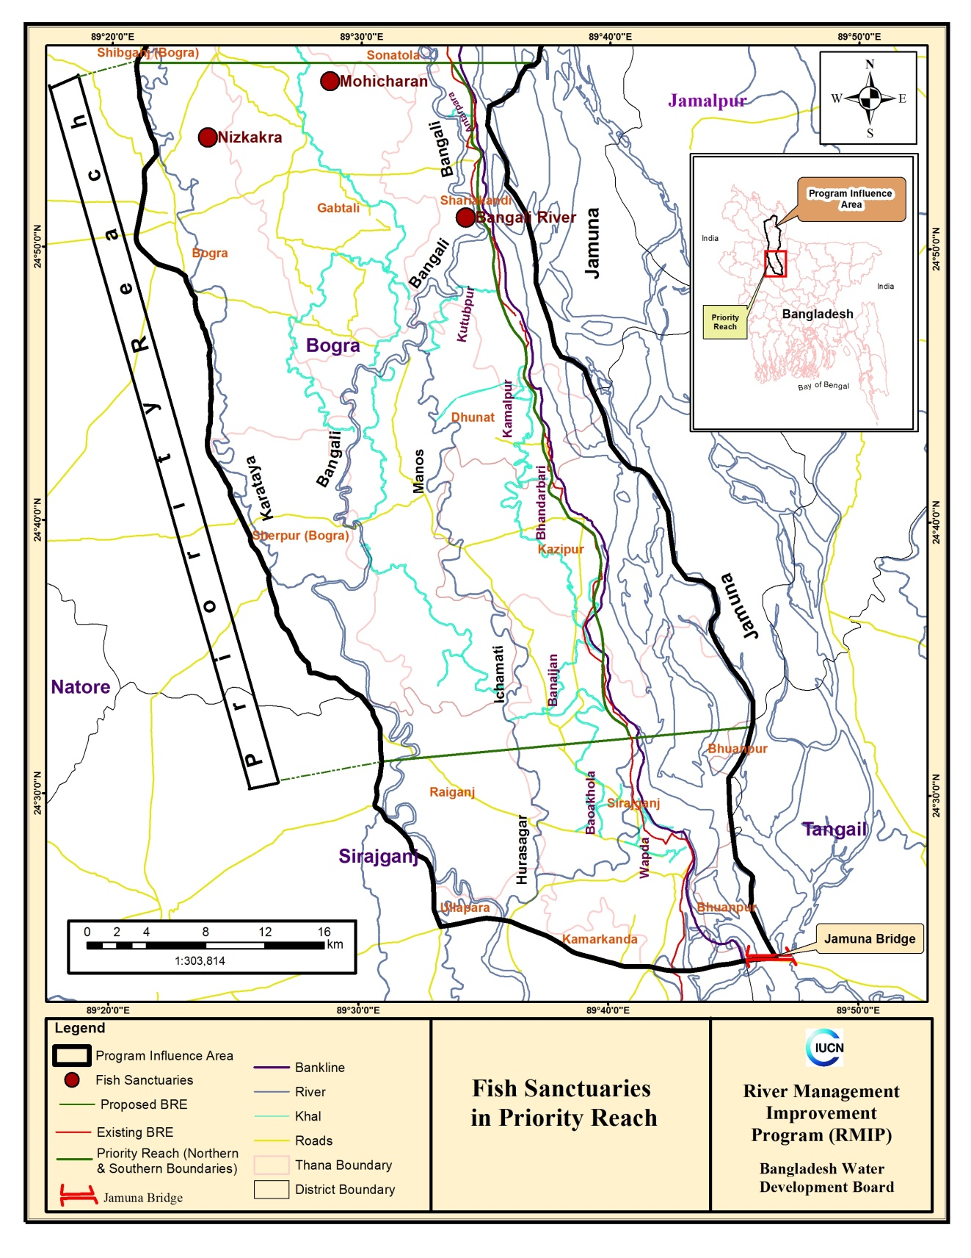
Figure 1: Location of the Fish Sanctuaries of Project Influence Area
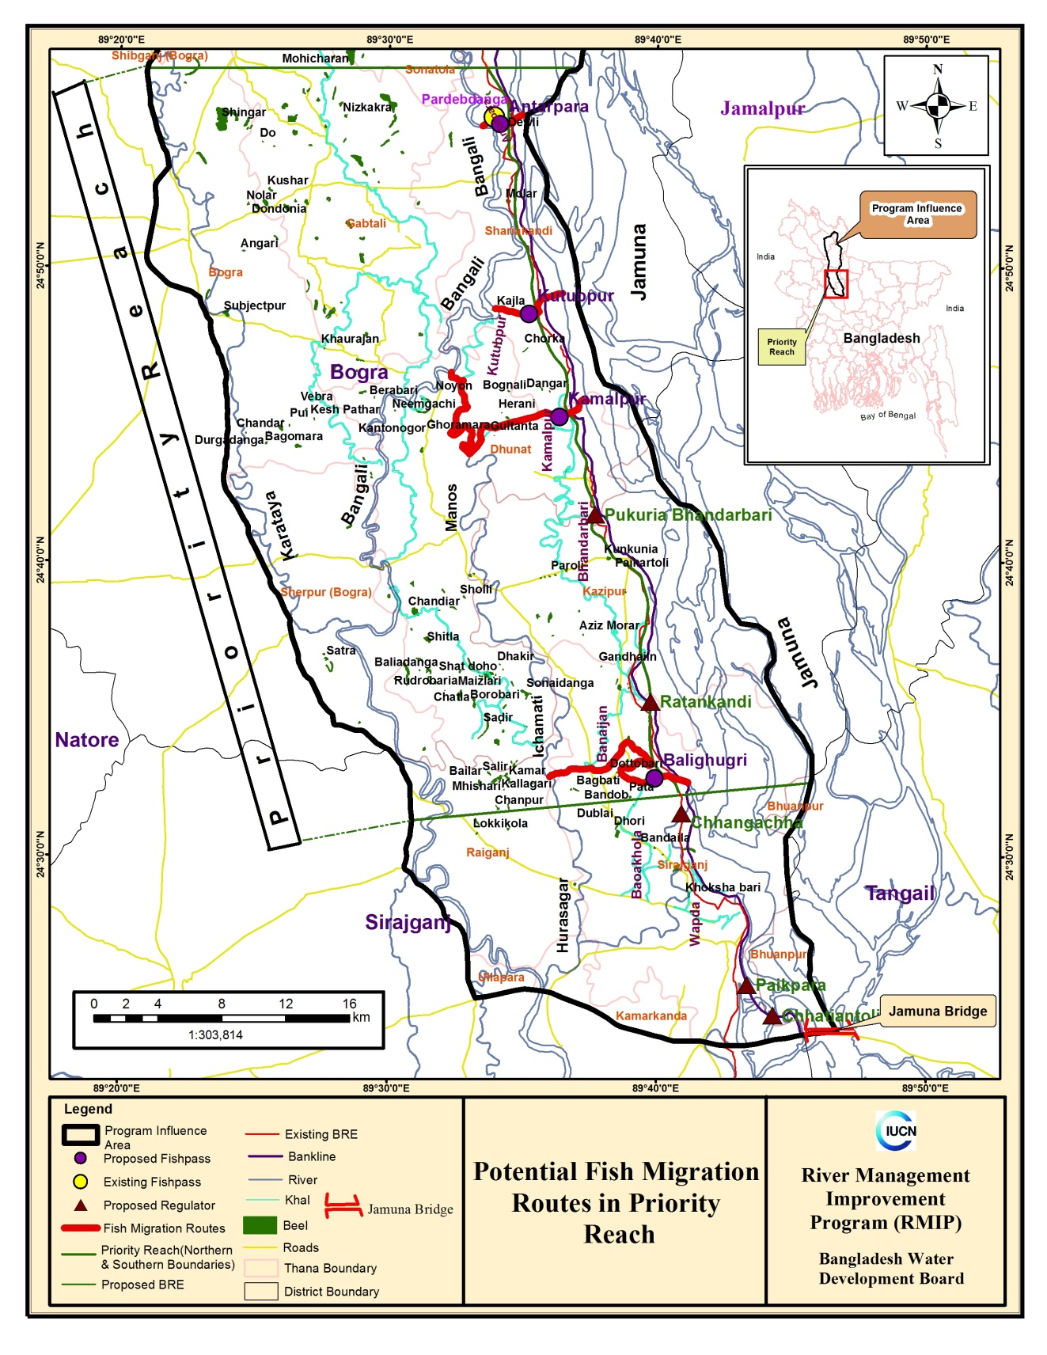Figure 2: Potential Fish Migration Routes through Fishpass in Project Influence Area

Detail Information Feasibility Report and EIA Report

